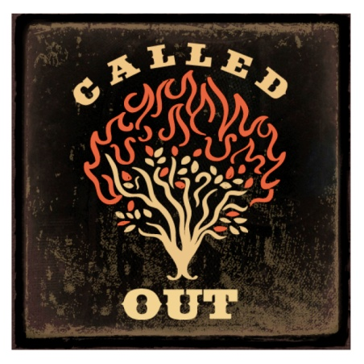
Leadership Training for Christ (LTC)
2014 Event Sign-Up Form
Please Print

Student

Parent(s)

Grade Gender F M T-shirt Size YS YM YL S M L XL 2X 3X

Email Address Cell Phone

Convention Events | Challenge Events | Pre-Convention Events
- Art  - Bible Bowl  - Bible Quiz  - Bible Reading  - Children’s Book  - Chorus  - Modern Drama  - Puppets  - Scrapbook  - Signing for the Deaf  - Song Leading  - Speech | - Bulletin Board  - Daily Devotional  - Leadership Challenge  - Reading Challenge  - Scripture Challenge  - Service Challenge  - Teaching Challenge  - Outreach Challenge | - Essay  - Fiction  - Poetry  - Audio Broadcast  - Song Writing  - Video Bible Drama  - Web Page  - PowerPoint  - Short Film
We have agreed on the event choices together and we commit to completing them within the established rules and deadlines. Our focus is steadfast on the message of the scripture.
Participant Signature Date Parent Signature Date

